VIRTUAL PROJECTS DONE

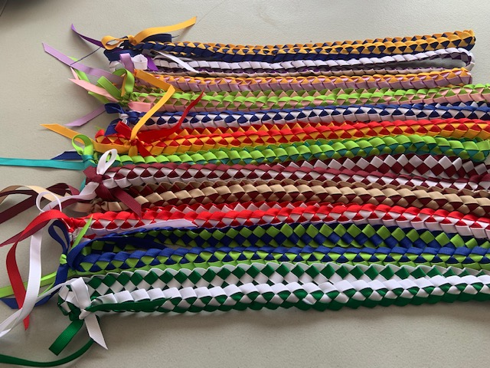
RIBBON LEIS:
The club approved money to support the lei project which Waiakea Key Club needed to support their virtual project with the elderly/ rehabilitation centers. The request for leis as awards for residence participation in daily living. Audrey went and bought assorted colors and made these leis and had some help from her daughter in law Chris. Audrey said when pairing the colors, it seems unlikely to be attractive, but after weaving the colors together, as you can see in the photo above, they ended very attractive. There is only a few more to go, and Audrey told Kari that it will be all done hopefully before Thanksgiving. Till today, she made 140 leis by herself and a few more to come.
The SLP is also doing many projects, including the face mask and no sew blankets and they will donate them to Kiwanis Family House, from the Opihi’s, Makai Key Clubbers, Kauai, Maui, and Big Island. They were fortunate that Governor Pete and Jeanette Edwards is on a trip to Kona and Audrey will be visiting them on the 14, 15, and Jeanette is a board member of the Kiwanis Family House and will take it back to them.. wow free postage.
NO NEW MEMBER FEE FREE TILL DECEMBER 30, 2020
Kiwanis International has changed the ruling due to Covid 19 for new members. There is no new member fees for International and District, but that is only till December 30, 2020, and more information to come. But this is one way of introducing your club on the virtual meeting to meet up with new members, and also to swear them in. I have delivered to our new members, and need to mail one more new member the pins and certificate. So help our club and recruit new members and let them meet the club members virtually. Talk to friends, invite them to be on virtual meetings with the club and introduce them to all the members on and they may see someone who they had know before. Help the club and increase membership and get them introduced before we go face to face projects or meetings. Good Luck. Application is available online with Kiwanis International, or contact Audrey and she will be able to send you one via email. Good luck to all of you for recruiting and taking advantage of the free membership.


KEAAU KEY CLUB
Keaau High School had contacted the Kiwanis Club of East Hawaii, and asked if they can have a Key club in Keaau High. Upon the request, Charlene and Audrey had contacted the club and will reactivate the club, the papers are in motion and the Faculty advisor is Emerald Kalai and the president is Jyxzel Bagaoisan. JP volunteered to be the Kiwanis advisor. More to come when the club starts and be activated. Charlene has the club in motion, she is having them make cards to be sent out.
Trustee Report
Here is some update from the many Zoom meetings I have been on throughout the month. The presidents will be requesting a waiver to be done due to the Covid spread, and the waiver is to excuse Kiwanis from any blame or liability of the disease, especially if you are planning to go face to face meetings in the near future. Also, Past Governor Timothy Cunning is now in the District office under the SLP Administration. The Mid year has been cancelled for North and South, but there is still a question on the District Convention as of this date. The many clubs in CNH is trying so hard to do fundraiser, projects and meetings, if you do any of the contact projects, please be aware there is mandated ruling in your area, and please abide them. Wear Face Mask, stay 6 feet apart for distance and Wash your hands always.. I have seen so many women who use the restrooms and flush the toilet and walk out of the restroom without washing their hands. I wouldn’t want to shake hands with that person.
No meeting place as of now.. but please Zoom with the club , notice of agenda is sent out with the link to the zoom meeting.

Meeting date on Friday’s at noon at E‘Komomai Restaurant every week.. Temporary on Corona Virus break. Notice for meetings will be sent to you by President Kelsey with agenda.


WHAT CAN WE DO…. The world is at a stand still and we must think of ways to get our goals accomplished. It is very sad that we cannot get together and talk and laugh and be active with our clubs. But time will come when we can return to the many activities we did before. So for now, we shall “ KEEP CALM AND CHANGE THE WORLD” to meet up to our goals with a little modification. Stay safe and take care of yourself and your love ones.
SLP REPORTS

Waiakea High School Ongoing projects are lei making, no sew blanket, thinking of you cards, etc.
Hilo High School no report, they have ongoing project online or at home. New members were inducted
Circle K UHH no report, doing distance studies
Waiakea Builders no report.
Aktion Club Easter Seals no report.

*** PROJECTS TO COME
NONE AVAILABLE NOW.. PLAY IT COOL… DO FAVORS FOR SOMEONE.

ZOOM, ZOOM

Due to the Coronavirus, all business is being done on the computer and we are all zooming to have our close up meetings. For all the members who are struggling with the process, (like me), ask a teenager and they can solve the problems for you
“ Success is going from failure to failure without loss of enthusiasm .
Winston Churchill

