WE ARE LOSING 3 KIWANIS MEMBERS…

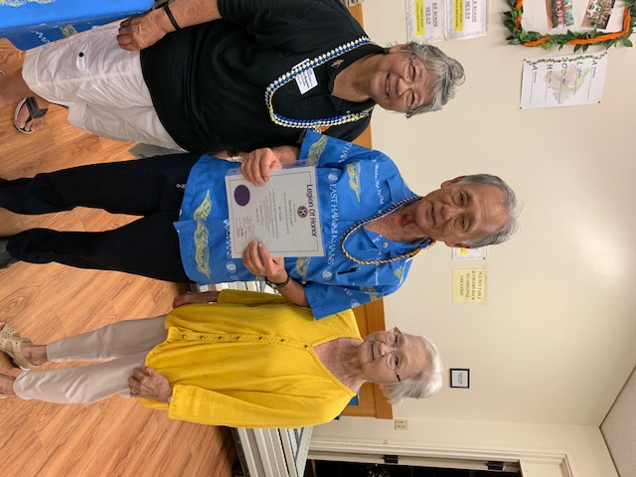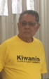
Harold Uyeno Ken Kumasaki Krystal Pilor
Harold Uyeno has been a member with our club for over 40 years, he served as President in 1994 and also Secretary and board member. He chaired the successful International Miso Soup Breakfast for many years, and also many other projects, and he has been very instrumental in introducing his projects and involvements. Thanks Harold for your contribution and commitment to Kiwanis of East Hawaii Club.
Kenneth Kumasaki, a very dependable member who has served as treasurer for many, many years. As treasurer he has kept the Activities and the Administration records with no complaints of over spending .. He stepped up to be the treasurer when no one wanted the job, maybe his arm got twisted. Thanks to Ken that all of the financial reports got recorded and no errors noted, he did this with his own hands, he just used the basic, INCOME AND EXPENSE, no fancy hard to learn method. Thanks Ken.
Then we had a short term member from First Hawaiian Bank,
Krystal Pilor who helped us with the Foundation account. Thanks Krystal, hope you return to us one day.

PROJECT WITH HILO KEY CLUB FOR THE FIREMEN OF HILO
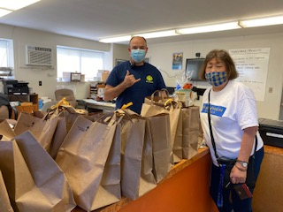
Charlene meets up with the Fire Department to deliver all the bags of goodies

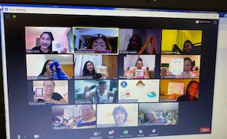
Virtual instructions given to make the eyelash lei and cookies from a cake box, and card.

The Kiwanis Club and the Hilo High Key Club had agreed to do a project that the Key Club designed for the Fire Prevention Week, and honor the Firemen, EMT, at the Hilo stations. 5 Kiwanians, Taylor and Megan Escalona, Cecily, Liz, and Audrey the support team, Jp, Roy and James, who helped with this project. In each bag had an eyelash lei, a card of appreciation, and cake mix cookies and lots of LOVE. Maybe next time the other members will have the chance to help with the virtual project and honor a organization who need the pandemic BOOST, to get through this trying time of boredom.


PAID YOUR DUES ???….
MAIL IT TO LAUREN NISHIMOTO AT P.O.BOX 44 HILO, HI 96721,,, AND OR LET ME KNOW THAT THE CHECK IS ON ITS WAY… THE DUES IS $150.00 PER MEMBER, ex Key Clubbers is $50.00 if you had joined after 2017. If you know the amount you owe, you can contact Lauren at laun1946@gmail.com The cost of your dues .. the breakdown you paid for the following.
- International Dues $77.00
Part of the $77.00 is for ….
$13.00 liability
$4.00 Director/officers insurance
- District Dues $51.00
- Club Dues $22.00
Total $150.00
Trustee Report
I am on Zoom for meetings and workshops and everything has to be done at a distance. At this time, there is not much to report except that all communications, will be zoom or email. Incoming Ltg Joy Nishida from the Kaneohe Club will be online also, and so we live with this for a while. I hope that all members can go on to Zoom and join the rest of the members and get to know what is going on with the club and Division . All clubs need to pay their membership to Kiwanis International in October, so if you have not paid it yet, please make your payment to your club.

SLP REPORTS

Waiakea High School Ongoing projects are lei making, no sew blanket, thinking of you cards, etc..
Hilo High School Happy cards were given to the seniors, care homes, etc.
Circle K UHH no report, doing distance studies
Waiakea Builders no report.
Aktion Club Easter Seals during the break, they had a food drive for those families who did not have enough food. Donation done by members and family.
NEW MEMBERS INDUCTED
- ALYSSA OKAMURA
- FRANCINE GALEGO
- JAMAE BALAGOT
- JAMES KAGAWA
- NICK YAMAMOTO
- QIANA MIPRANO

*** PROJECTS TO COME
NONE AVAILABLE NOW.. PLAY IT COOL… DO FAVORS FOR SOMEONE.
New project, to assist Kari with the ribbon let, the club has some ribbons to be made. Audrey has the various colored ribbons available, please ask for some. Please let Audrey know if you can do some ribbon leis for the club.
Kari is asking for leis and if you have some that was presented to you before, or if you would make some leis, call Kari and she will be happy to pick them up.


WHAT CAN WE DO…. The world is at a stand still and we must think of ways to get our goals accomplished. It is very sad that we cannot get together and talk and laugh and be active with our clubs. But time will come when we can return to the many activities we did before. So for now, we shall “ KEEP CALM AND CHANGE THE WORLD” to meet up to our goals with a little modification. Stay safe and take care of yourself and your love ones.

“When you get to the end of the rope, tie a knot and hang on.” Franklin D. Roosevelt

