COVID HITS HILO
Feb. 20, 2021
COVID VACCINE GIVEN
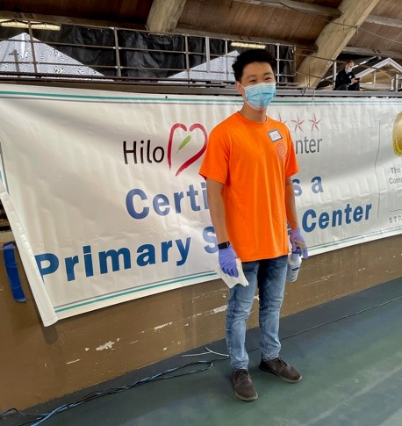
Casey, our newest member at work.. thanks for coming
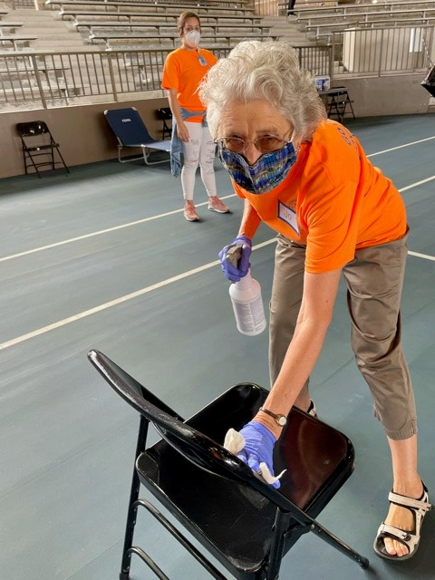
Jo cleaning the chairs for the incoming participants
As seen above, Casey is waiting for participants to come to the area for waiting after to vaccine was administered. And Jo, she is cleaning the chairs after the participants has left to continue with the process of the vaccination . Thanks to Jo, Les, Liz, Tom, Taylor, Casey, Kelsey, Jon, Most members were happy to do this volunteer work, but the standing was really long for most of the members, getting sore legs and back. So, the program chair had cut the day in half for the March 13 drive and so most of us volunteered for the morning or the afternoon. Thanks to the members who generously gave their time to do this project. Our Kiwanis Club was mentioned as one of the volunteers in the Tribune Herald on March 14 newspaper..

AGAIN
WE DID IT.. MARCH 13
COVID VACCINE CALLS
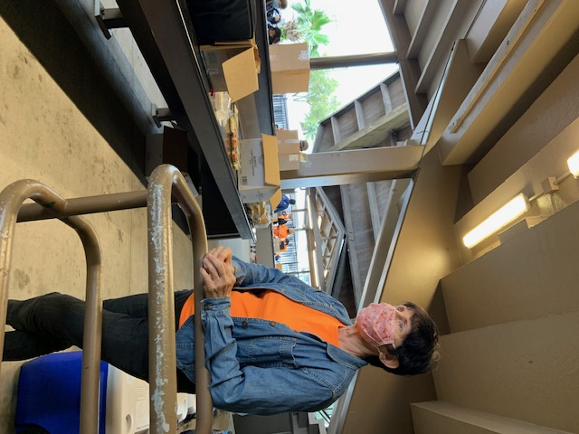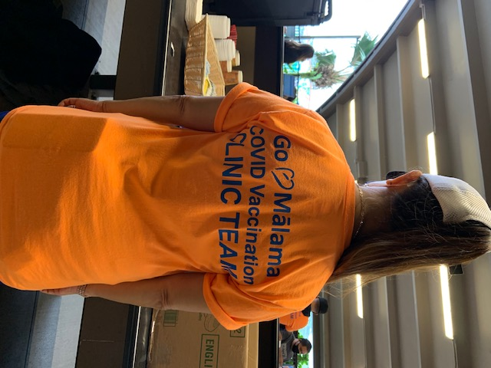
Liz waiting to serve food The back view of the shirt worn.
The Hilo Hospital Covid program called out to organizations to assist with the Mass production vaccine at the Kanakaole Tennis Stadium where they will be vaccinating more teachers and workers that is needed covid support in our community. So, Jo, Les, Taylor, Tom, Kelsey, Francine, Taylor, Liz, and Audrey, showed up and did various chores for the program. As you can see we did a lot of chores and now the Kiwanis Club of East Hawaii is on the front line doing what needs to be done for tis pandemic emergency. The project covered 4,000+ covid shots Thanks to the many volunteers who showed up and did their part in the program.
Trustee Report
This month, the Trustee reports to you - be safe and healthy, and hopefully we can all go to the Kiwanis International Convention on June 23-26 in Utah. And to follow with a visit to San Diego on August 19 to 21 and meet everyone in person with mask on and distance control. I also would like to ask all clubs to look around your club for past Presidents to help Div. 22 with a Ltg. for 2021-2022. Some clubs has not been represented by a Ltg. for years. Please consider.. let Joy or myself know you are interested.
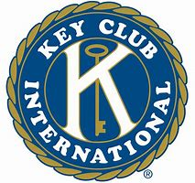KEA’AU KEY CLUB
CHARTERED 1/5/2021
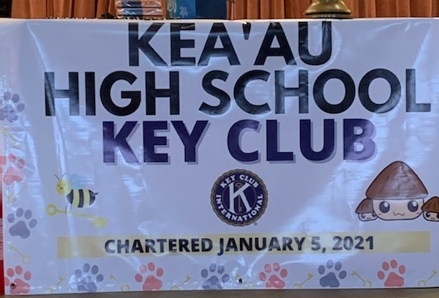
Outside banner for the club made and donated by the Hilo High Key Club.
Cup cake of Bees ▼↓
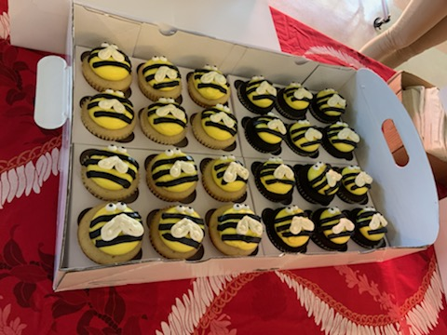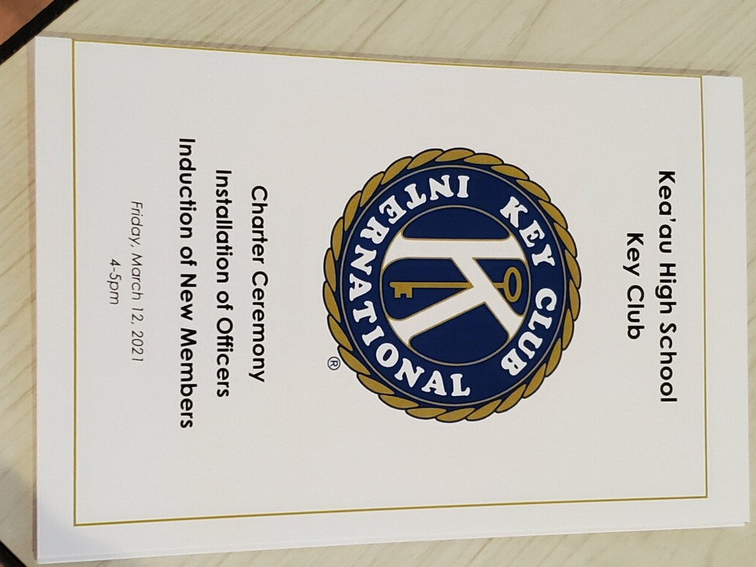
SNACKS wow.. Hilo High Key Club provided the new members and an Invitation was made for limited invite.

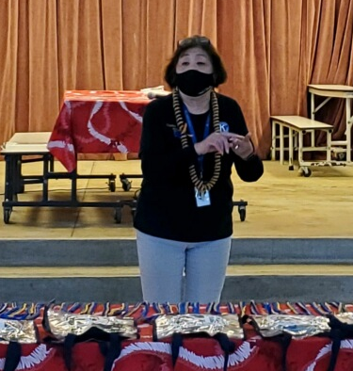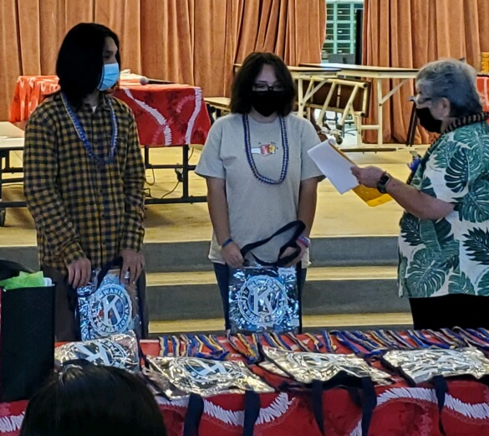
Charlene explains Key Club Audrey swear in Pres.
Purpose ▼ Jyxzel and VP Melody
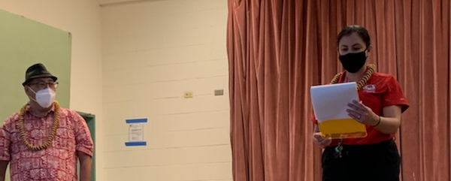
Edwin Kagawa, Kiwanis Advisor, Emerald Kalai Faculty advisor
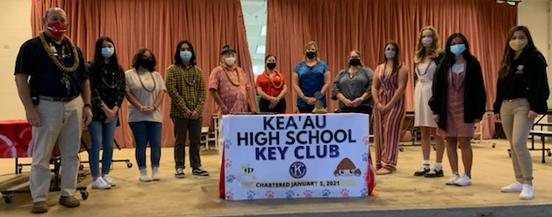
Principal Dean Cevallos, advisors and members of the Key Club
Keaau High School, had their charter on Friday, March 12, and now they are moving, with 25 members Faculty Advisor Emerald Kalai and Kiwanis Advisor Edwin Kagawa. On schedule and planning for the community with support bags will be given to those on the streets in Hilo town possibly March 17
Members are as follows:
President Jyxzel Bagaoisan
VP Membership Melody Padilla
VP Service Crystal Toyama
Secretary Catherine Nishida
Treasurer Germaine Saladino
Macayla Adams Keivina Boaz
Nicholas Boo-Rivera Noelleen Dela Rosa
Alfredo III Gani Harley Habu
Owen Hernando Shayla Kaheaku
Kassidy Lucas Roanne Mendoza
Mauren Moreno Dakota Muranaka
Kamaile Paikuli Keesha Payne
Angel Picanso Arieta Shipman
Madelyn Smith Xiaoshun Sun
Jadelyn Villegas Sunny Gnechten
The Kiwanis Club of East Hawaii welcomes you to the family and let us work together and always, you have a family of SLP with us, they are Waiakea and EB deSilva K-Kids, Waiakea Intermediate Builders, Aktion Club of Easter Seals, and Circle K of University of Hawaii at Hilo. Please join us on the first Wednesday of the month at 5 pm to join in the board meeting and contribute your monthly calendar to be approved by the board. Any questions, call on us.

Meeting date on Friday’s at noon at E‘Komomai Restaurant every week.. Temporary on Corona Virus break. Notice for meetings will be sent to you by President Kelsey with agenda.
SLP REPORTS
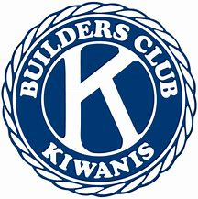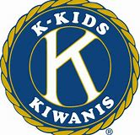
Waiakea High School Doing lei making, card making to give the elderly facilities, and doing projects with the school
Hilo High School Doing card making and giving to the care homes, doing projects with the school
Keaau High School Had one board meeting to plan activities while waiting to get chartered.
Circle K UHH no report
Waiakea Builders no report.
Aktion Club Easter Seals no report

