AGAIN
COVID VACCINE AGES 12 AND OLDER
May 15, 2021
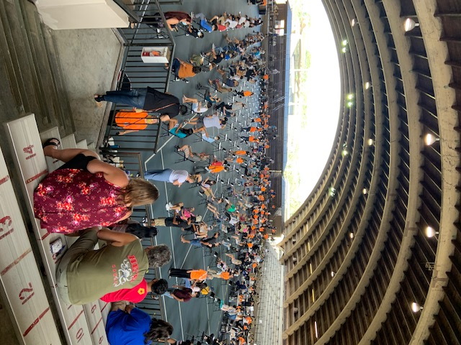
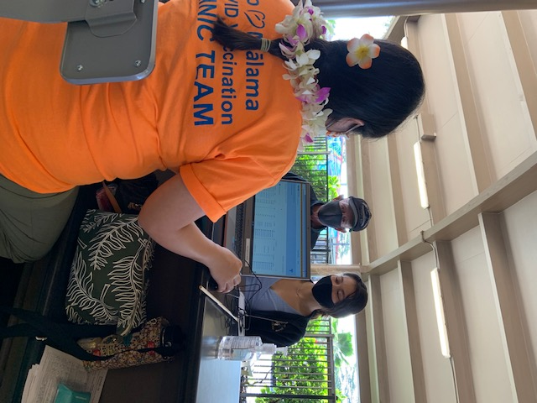
Members were happy to do this project for this is the last mass covid vaccination for the public at the tennis stadium. Members who were helping was Kari and her WHS Key Clubbers, Audrey, Kelsey, Tom, Les, Jo, Liz, JP, Jamae, and Francine. It was so nice to see the younger students getting their shots in time for the summer and school to start in August. Parents there were happy also to have the opportunity to have their children getting the shots. The stadium was packed with so many from the community and even some parents got the shot to prove to their child that it did not hurt at all. Thanks to Hilo Hospital for giving the effort one more time to help with the pandemic and protect the community. I had helped with the food distribution to the workers and it was so nice to see many volunteers happy and giving up their time to support the community in this massive vaccination for all.

Xochi Gervais from Hilo High Key Club signing in for the shot with Grandpa.
JARED PROJECT
KIWANIS AND KEY CLUBS 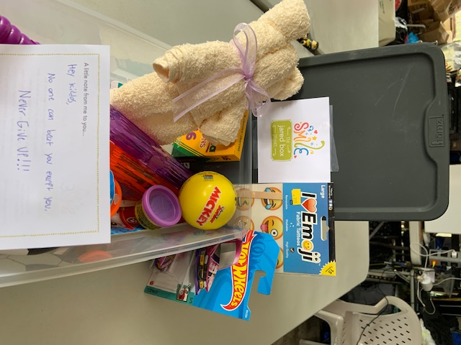
This is one of 40 boxes made and donated to Hilo Hospital Pediatric Ward
A Jared box project email was sent to Audrey and she had contacted Hilo Hospital to see if they would like to participate in this donation of shoe boxes of goodies for children in the hospital with long stays. The hospital accepted and was happy to be a part of this project, so the story goes and the Kiwanis Club started the project chaired by Taylor and the 3 Key Clubs, Hilo, Keaau and Waiakea Clubs and so we ended up with 40 shoeboxes with lots of great things for the certain age group as identified on the box. For the clubs, I heard that it was fun and getting the club involved during this pandemic time is so exciting. There is a note of cheers from the organization, written in their own handwriting. If anyone would like to get more information, you can call 814-883-5615, or email cindy@thejaredbox.com or visit the website at www.thejaredbox.com you can also donate money to the organization, but our club wanted to leave the project in our town.

SLP REPORTS
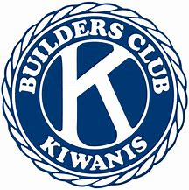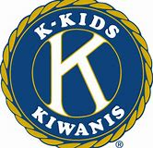
Waiakea High School Doing lei making, card making , planning social with Waiakea Builders.
Hilo High School Color a smile, drawing for Senior Citizens, Pots for Tots, Unify Zoom, assist with graduation, lei making, ballons, and decorate
Keaau High School plan activities , Jared Project, Rice, Miracle Miles, UNICEF math challenge and participating in Keaau Graduation
Circle K UHH no report
Waiakea Builders no report.
Aktion Club Easter Seals no report

Trustee Report
This month, the Trustee reports to you - be safe and healthy, and hopefully we can all go to the Kiwanis International Convention on June 23-26 in Utah. And to follow with a visit to San Diego on August 19 to 21 and meet everyone in person with mask on and distance control, or, we can sign up for virtual connection for a cost. I would like to thank Jonathan Oshiro from the Honolulu Club for volunteering for the Division 22 Ltg. At this time, we need to plan out our future years and get out club past presidents to help the division and take the next years Ltg position. At this time, we are doing virtual connection , so maybe the travel to meetings for all during the year, will be your choice of in person. I know the Ltg. training will be expected to be in person in Rancho Cucamonga and the District convention and Mid Year is a must to be in person.. But if cannot, I am sure there will be virtual communication. I just got off the Ltg elect training with Margo Dutton, and if you have not gone on, go to the district office and connect the virtual training that was presented today, they also talked about the CLE training. Take care and see all of you soon.

Meeting date on Friday’s at noon at E‘Komomai Restaurant every week.. Temporary on Corona Virus break. Notice for meetings will be sent to you by President Kelsey with agenda.


From: KIWANIS CLUB OF EAST HAWAII
CONGRATULATION TO …

HILO HIGH GRADS:
Cami Wong
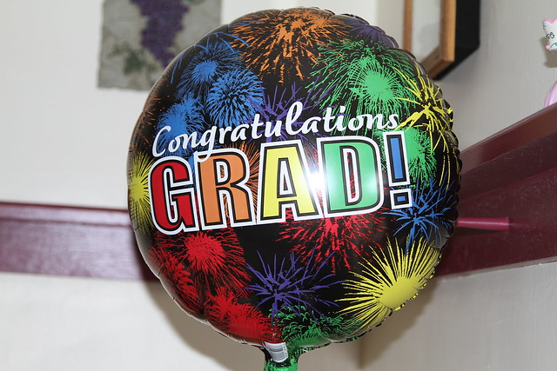
Ashley Lavaris
Cami Oyama
Chanelle Hwang
Cain Ross
Cheves Kaohe
Cody Stephenson
Hunter Okumura
Kysha Rae Pacheco
Smantha Chung

KEAAU HIGH GRADS:
Nicholas Boo-Rivera
Shayla Kaheaku
Keesha Payne
Angel Picanso

WAIAKEA HIGH GRADS:
Kaylen Hamora
Patricia Saiki
Saedie Wakida

The Kiwanis Club of East Hawaii congratulate you for all you have achieve from the 12 years of education in school. The years you have spent with the Key Club would have been more eventful, but due to the pandemic, things had to be modified and changed. The Kiwanis Club wishes you the best in the future, and make the most of the years to come. Congratulations and best wishes.

