HAPPY NEWS FOR
BUILDERS CLUB

Hilo Intermediate School
Happy news finally, Charlene reported that the Builders at Hilo Intermediate is having a start, maybe for the next school year, the club can get started again with a new faculty advisor. If we get the advisor, we may start on October 1, 2021.

Keaau Middle Scool
Kiwanis Keaau Key Club Advisor Edwin Kagawa had set up a possibility for a Builders Club at Keaau middle school for October 1, 2021, as he has contacted a few teachers to be the faculty advisor for the club, although Edwin will be leaving Keaau Middle School next year, and will be at Keaau High School, he is willing to be the Kiwanis Advisor for this Builders club.

Waiakea Inter. School
Builders at Waiakea Intermediate will continue on and still having the same faculty MJ Tominaga.

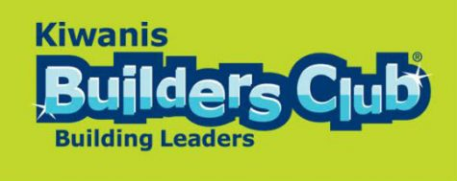

KI Convention In Utah continues with the convention next weekend from June 23 – 26. There will be virtual connection for the convention for $39.00, and the chosen hotel is the Marriot for CNH District



CNH CONVENTION
SAN DIEGO, CA.
The CNH convention will be held in San Diego and we will be staying at the Sheraton Marina. The convention committee has a plan for all of the members to have a nice time and get lots of education on Kiwanis operations and programs.



SLP REPORTS

Wanaka High School volunteered for Coved vaccine, made leis for grads, J8 summer will do recruitment and make blankets
Hilo High School Prep letters for Seniors and diploma, project grad, mask , landscaping done for campus, patio tables , vaccination Coved clean up after commencement
Keaau High School no report at this time.
Circle K UHH no report
Waiakea Builders no report.
Aktion Club Easter Seals no report

The Kiwanis Club of East Hawaii wishes all the Dads a Very HAPPY FATHERS DAY…



Since we were in the house for over a year and a half, here is something for you to do while sipping on your coffee or your beer… have a nice time playing with this game
E.B.deSilva Elementary needs help
July 20, from 8 to noon, Kiwanis has a project with E.B.deSilva Elementary School doing all kinds of chores to beautify the campus, paint trash cans, safety marking, all kinds of chores.. if you can, please let Cecily know by June 28 if you will be there so planning for the project can proceed.
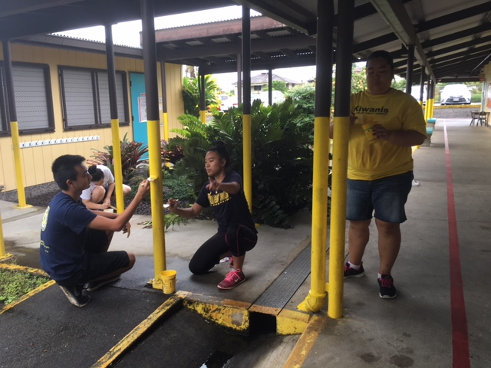
Trustee Report
This month, the Trustee reports to you - be safe and healthy, and hopefully we can all go to visit San Diego on August 19 to 21 and meet everyone in person with mask on and distance control, or, we can sign up for virtual connection for a cost. I would like to thank Jonathan Oshiro from the Honolulu Club for volunteering for the Division 22 Ltg. At this time, we need to plan out our future years and get out past club presidents to help the division and take the next years Ltg position. At this time, we are doing virtual connection , so maybe the travel to meetings for all during the year, will be your choice of in person. I know the Ltg. training will be expected to be in person in Rancho Cucamonga and the District convention and Mid Year is a must to be in person.. So think about helping the district and take a challenge to be a district officer when asked. you are asked if someone knows that you can do it.

Meeting date on Friday’s at noon at E‘Komomai Restaurant every week.. Temporary on Corona Virus break. Notice for meetings will be sent to you by President Kelsey with agenda.

